Sriracha Artichoke Hummus

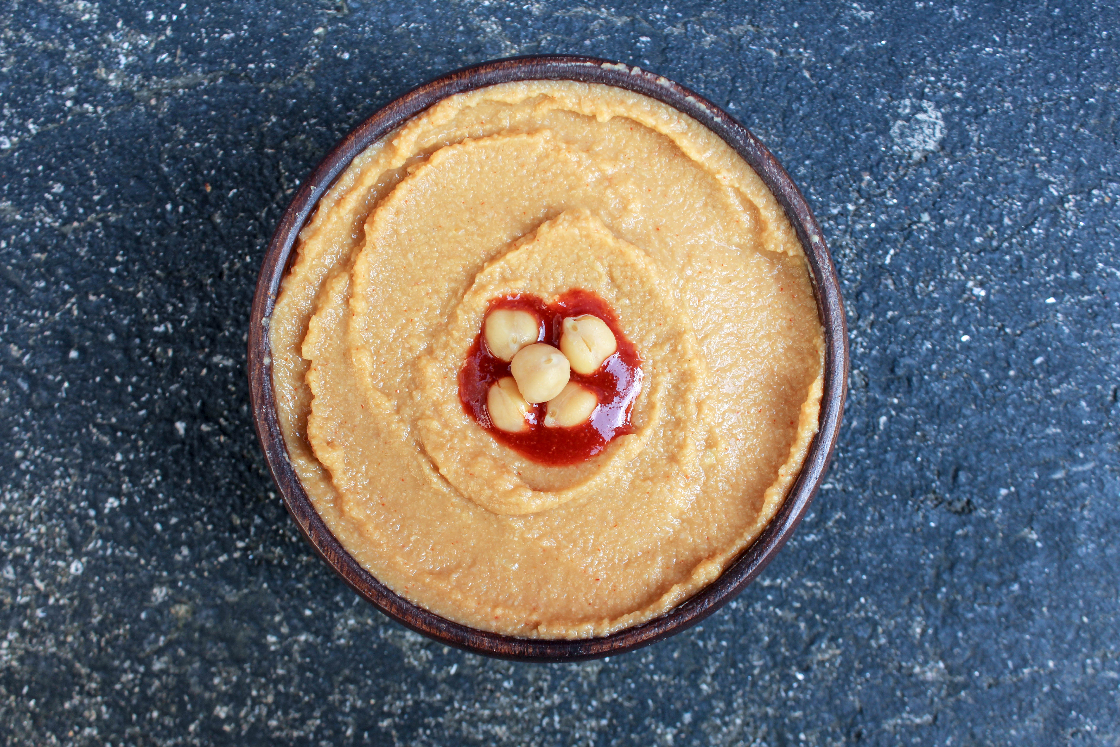

This is probably my favorite hummus I’ve ever eaten. I like homemade hummus a lot better than store bought, and once you make this I bet you will too! The base of this recipe without the artichoke or sriracha is from Engine 2, and you can add different ingredients to your liking to play around with different flavors. It is also a lot healthier than store bought because it doesn’t have added oil or preservatives, but it holds up for a couple weeks.

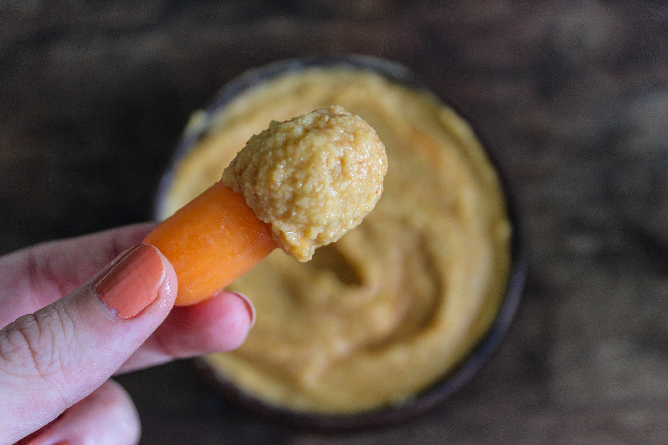

Recipe:
2 Cans of Garbanzo Beans, drained and rinsed
Juice of 1 Lemon
3 teaspoons of Garlic (you can add more or less if you desire)
2 teaspoons of Cumin
2 teaspoons of Bragg Liquid Aminos
¼ cup of water
1 Can of Artichoke hearts
2 Tablespoons of Sriracha (again you can add more or less, if you prefer it spicier or more on the mild side)

Blend all ingredients in a food processor or blender until creamy and smooth. Enjoy!

