Tomato Meat Sauce Over Spaghetti Squash

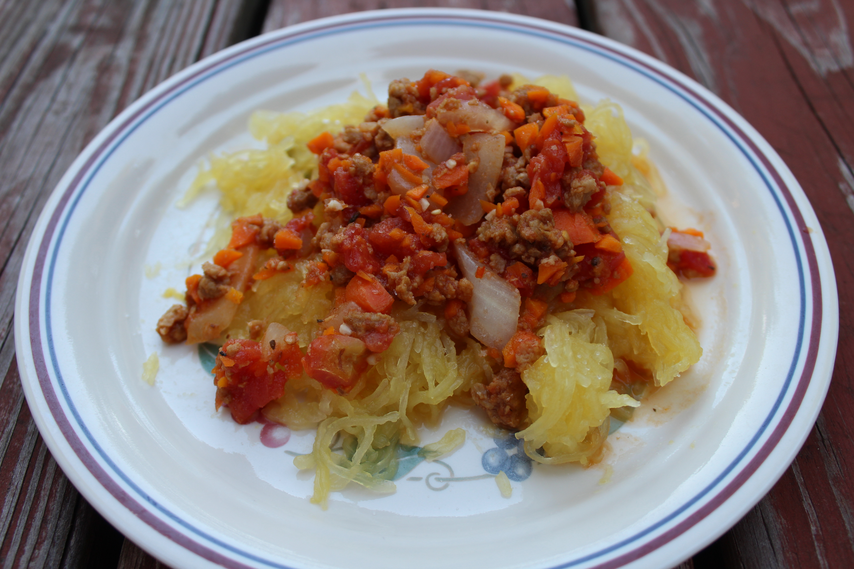
This recipe is so delicious! Its quick and easy to make and healthy! My mom used to make this sauce when I was younger from an old Weight Watchers Recipe. Its really versatile, I made it over Spaghetti Squash but you could put it over pasta or a bed of mixed greens for a lighter option! I decided to try out Beyond Meat Frozen Beef Crumble, which is a Vegan plant based meat substitute, and boy was it amazing! It was hard to tell the difference, the texture and flavor was perfect! Good Luck, hope you enjoy it!

Recipe:

2 tsp Olive Oil
1 Large Onion, chopped
1 medium Carrot, finely chopped
3 Cloves of Garlic
1 Bag of Beyond Meat Beefy Crumble (or 1 pound of Low fat Beef)
28 oz. can of diced Tomatoes
1 Spaghetti Squash (or one package of Pasta)
Red pepper, Salt, Pepper to taste

Instructions:

(If using Spaghetti Squash, you can either put one in a crock pot on low heat for 6 hours, or cut in half horizontally, cover with plastic wrap and heat in the microwave for 8 minutes)

Heat oil, onion, carrot and garlic in a large saucepan over medium heat. Cook for about 6 minutes.

Add beefy crumbles or beef and stir in until thawed or browned. This should take another 6 minutes.

Finally add in the tomatoes and continue heating and stirring until boils. Simmer until the sauce thickens a bit.

Add a little Red Pepper, Salt and pepper and enjoy!

