No Bake Carrot Cake Bites

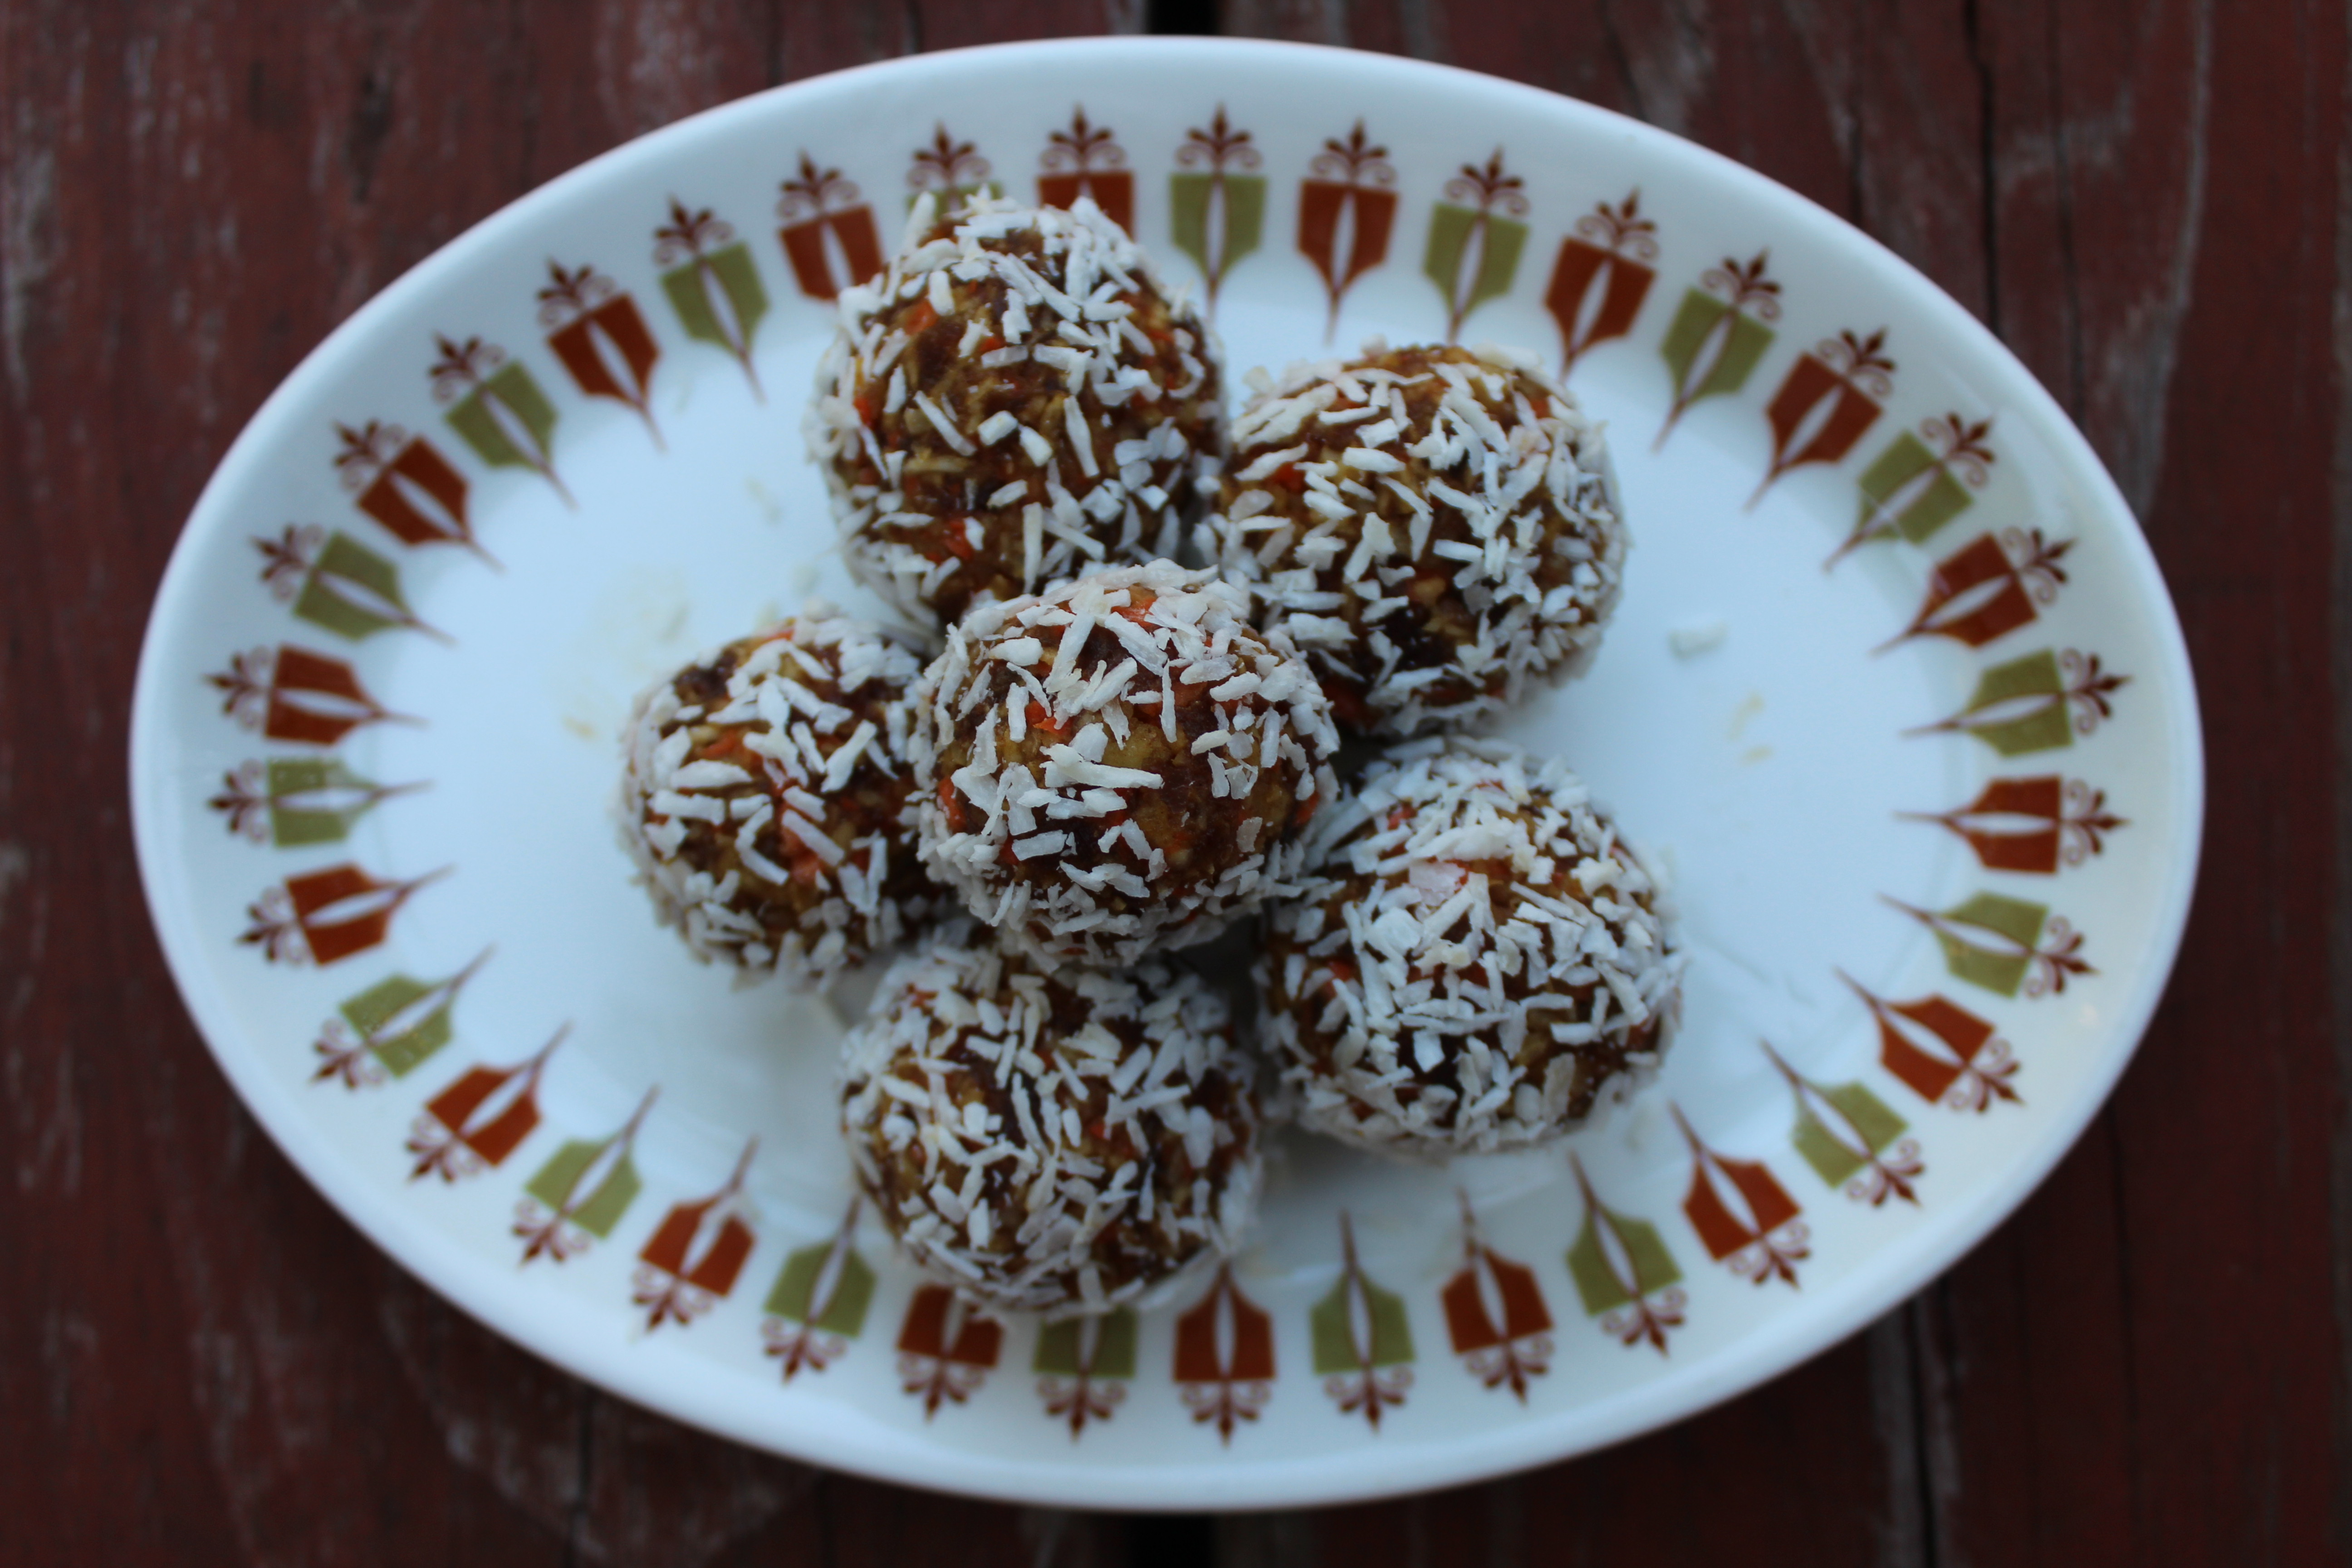
I have a major sweet tooth and I love creating recipes that are healthy alternatives to unhealthy desserts. You might not consider Carrot Cake to be that unhealthy, I mean it does have carrots, right? But carrot cake you buy at a typical grocery store can be loaded with sugar and oils!
Here is a super quick and easy, healthy Carrot Cake dessert (or snack) that I guarantee will satisfy your sweet tooth!

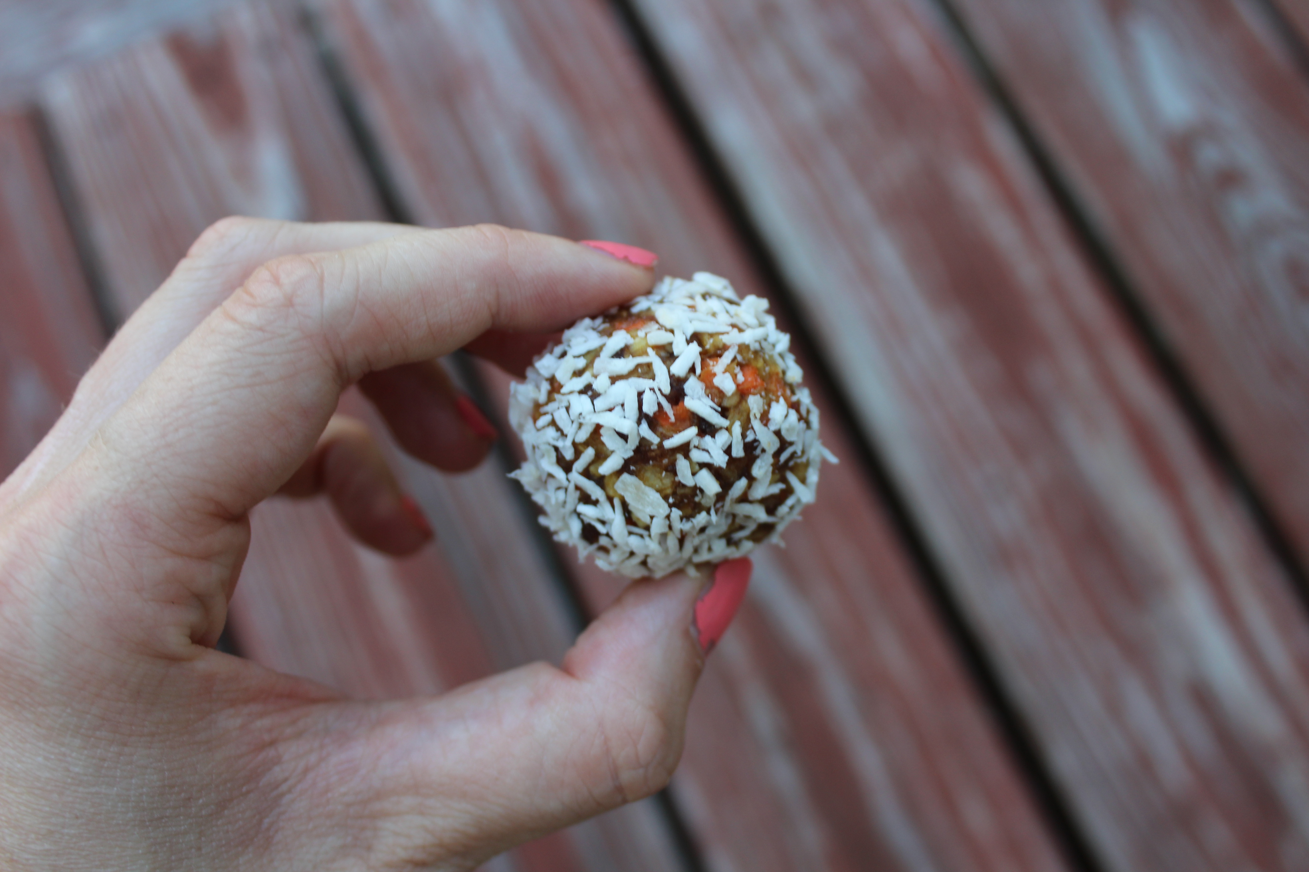

Recipe:

1 Cup pitted Medjool Dates
½ Cup chopped carrot
½ Cup of shredded coconut
½ Cup of chopped pecans
1 Teaspoon of cinnamon
Pinch of ginger
Pinch of nutmeg
2 Tablespoons of water (you can add a little extra if needed to form a thicker consistency)

Instructions:
Mix all ingredients in a food processor until it’s a thick dough consistency
Roll dough into golf ball sized bites- roll them in shredded coconut if you desire
Place on cookie sheet and pop into the freezer for at least a half hour
Enjoy!
